**TITLE OF LAB: (PROPERTIES OF CONTINUOUS TIME FOURIER SERIES)**

**LAB # 11**



**Spring 2022**

**CSE301L Signals & Systems Lab**

Submitted by: **Safi Ullah Khan**

Registration No: **20PWCSE1943**

Class Section: **B**

“On my honor, as student of University of Engineering and Technology, I have neither given nor received unauthorized assistance on this academic work.”

Student Signature: ______________

Submitted to:

**Engr. Durr-e-Nayab**

Day, Date (e.g Monday, June 20th, 2022)

**Department of Computer Systems Engineering**

**University of Engineering and Technology, Peshawar**

**OBJECTIVES OF THE LAB**

**‐‐‐‐‐‐‐‐‐‐‐‐‐‐‐‐‐‐‐‐‐‐‐‐‐‐‐‐‐‐‐‐‐‐‐‐‐‐‐‐‐‐‐‐‐‐‐‐‐‐‐‐‐‐‐‐‐‐‐‐‐‐‐‐‐‐‐‐‐‐‐‐‐‐‐‐**

This lab aims at the understanding of:

Properties of CT Fourier series

* Linearity
* Time Shifting
* Time Scaling
* Time Reversal

**‐‐‐‐‐‐‐‐‐‐‐‐‐‐‐‐‐‐‐‐‐‐‐‐‐‐‐‐‐‐‐‐‐‐‐‐‐‐‐‐‐‐‐‐‐‐‐‐‐‐‐‐‐‐‐‐‐‐‐‐‐‐‐‐‐‐‐‐‐‐‐‐‐‐‐‐--**

**-------------------------TASK 01--------------------------**

* Given the signal x(t) with ak’s

1. Plot the time reverse version of the signal x(‐t) directly,
2. Plot FS coefficients a‐k of time reversed signal,
3. Plot the reconstructed time reversed signal using FS coefficients a‐k

Hint: use **bk = fliplr(ak);** for flipping the ak’s.

**Screenshot of Input:**

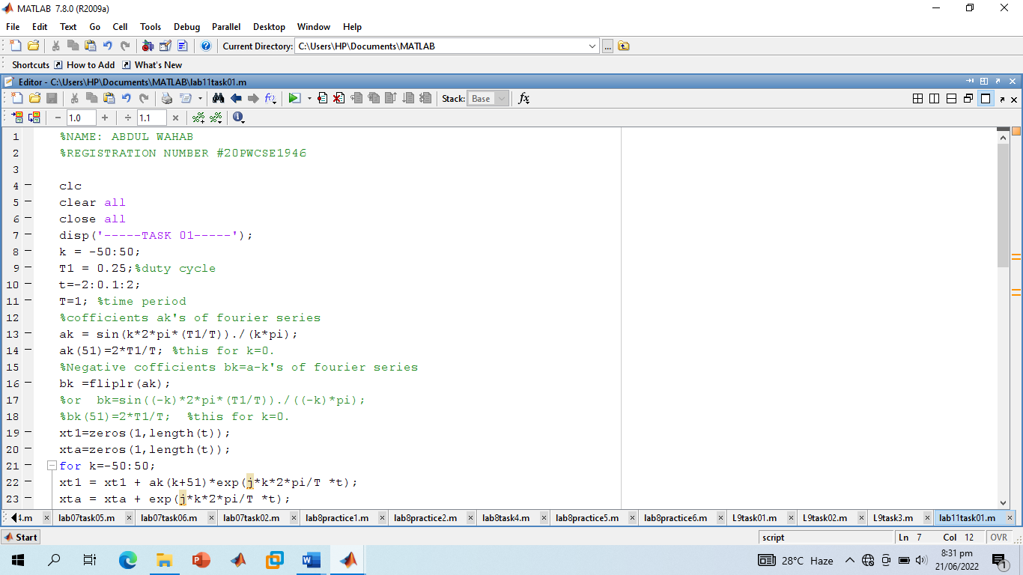

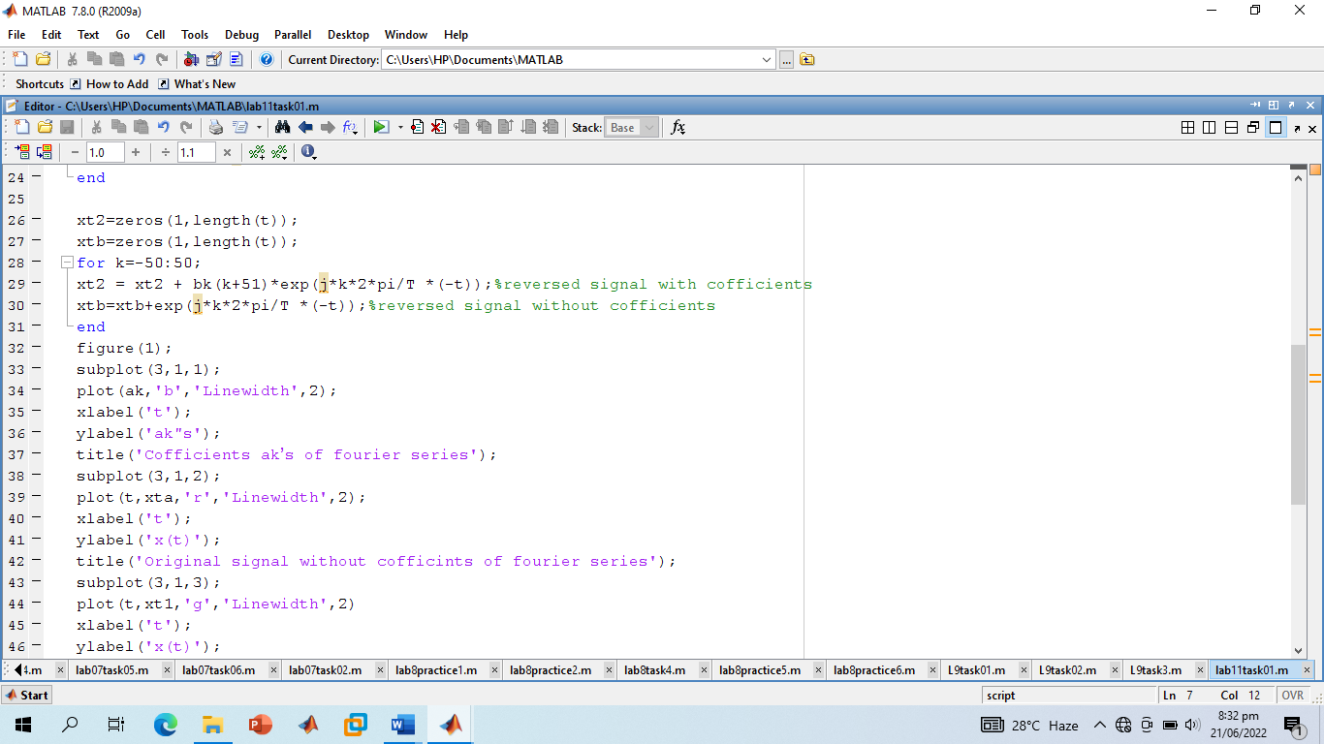

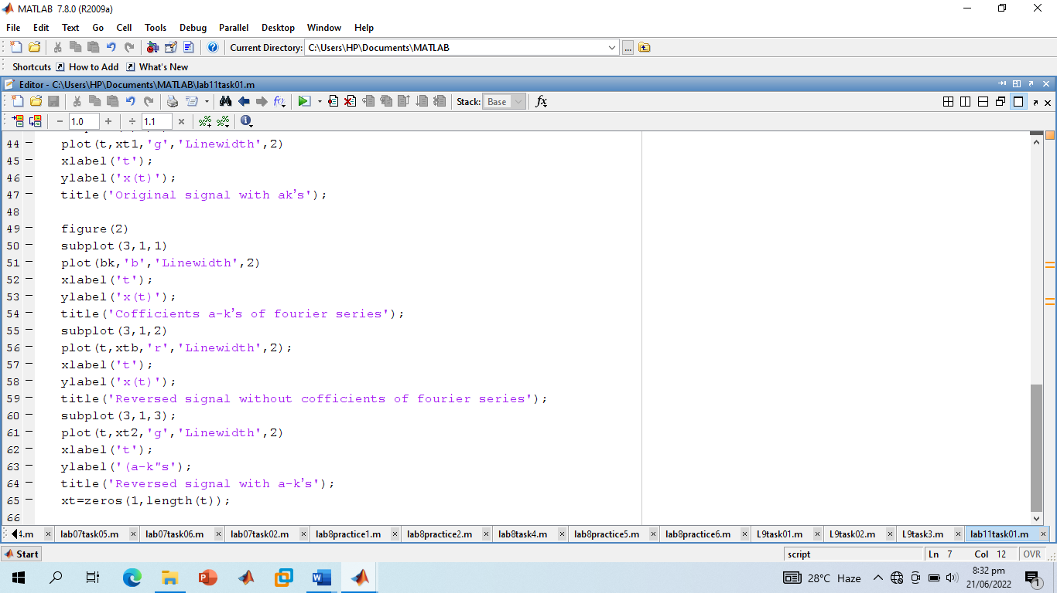

**Screenshot of Output:**

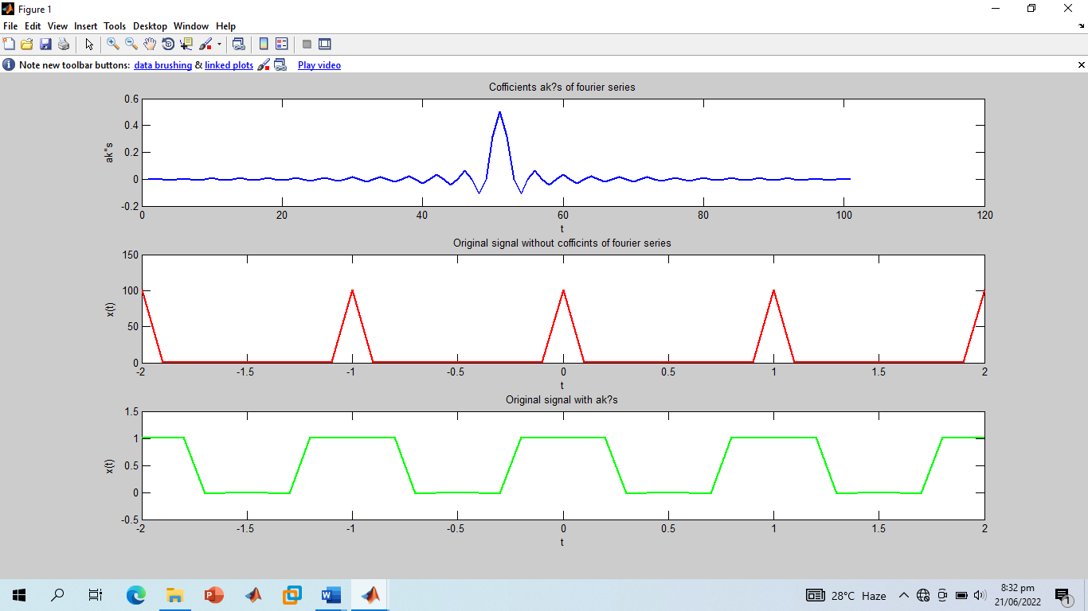

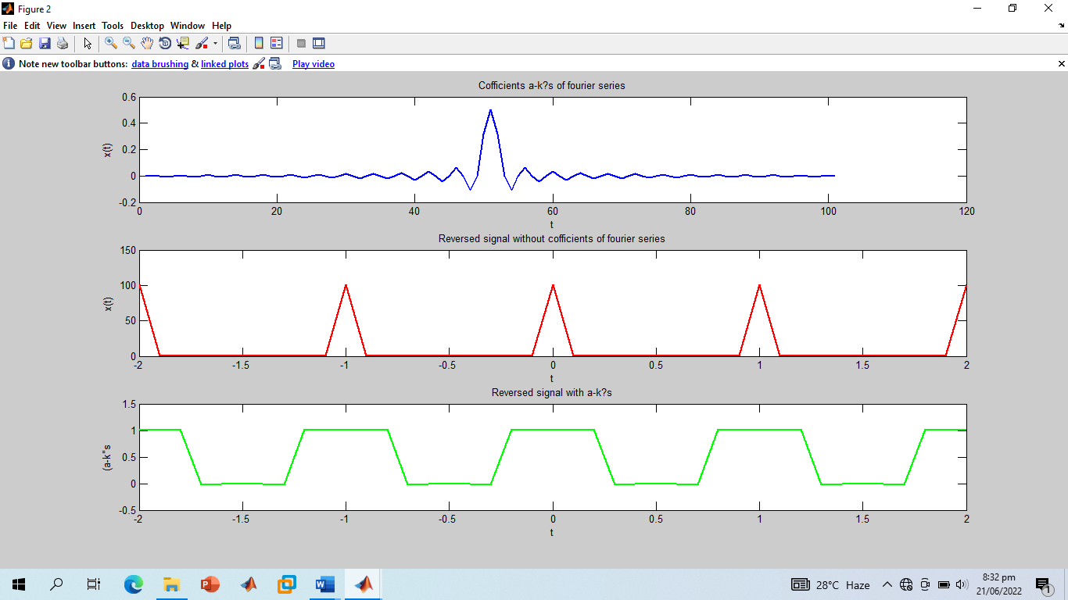

**-----------------------TASK 02--------------------------**

* Given the periodic square wave x(t) with T = 1 & T1 = 0.25, rewrite the above code for time scaling when value of alpha is 2 i.e., x(αt) = x(2t).

**Screenshot of Input:**

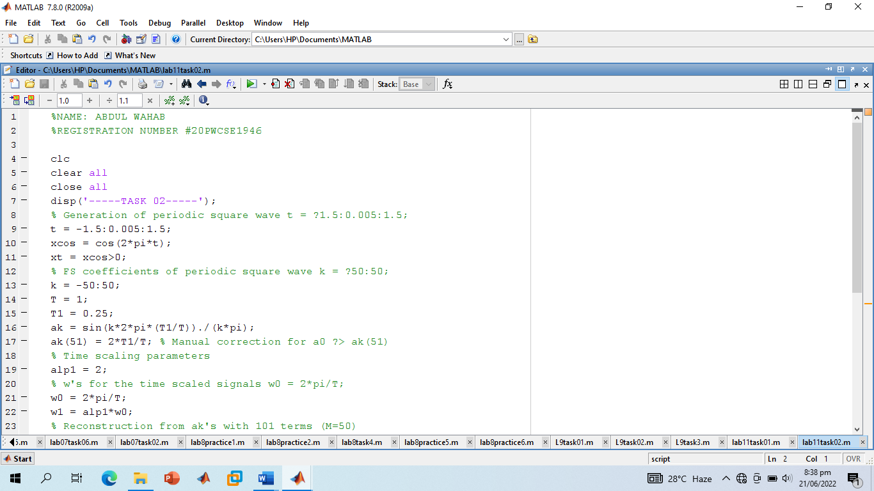

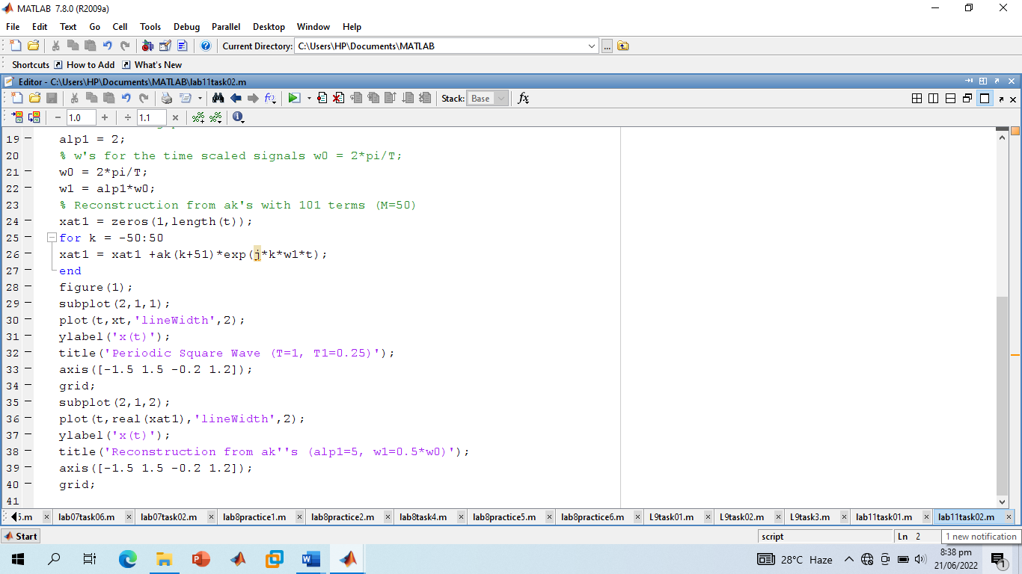

**Screenshot of Output:**

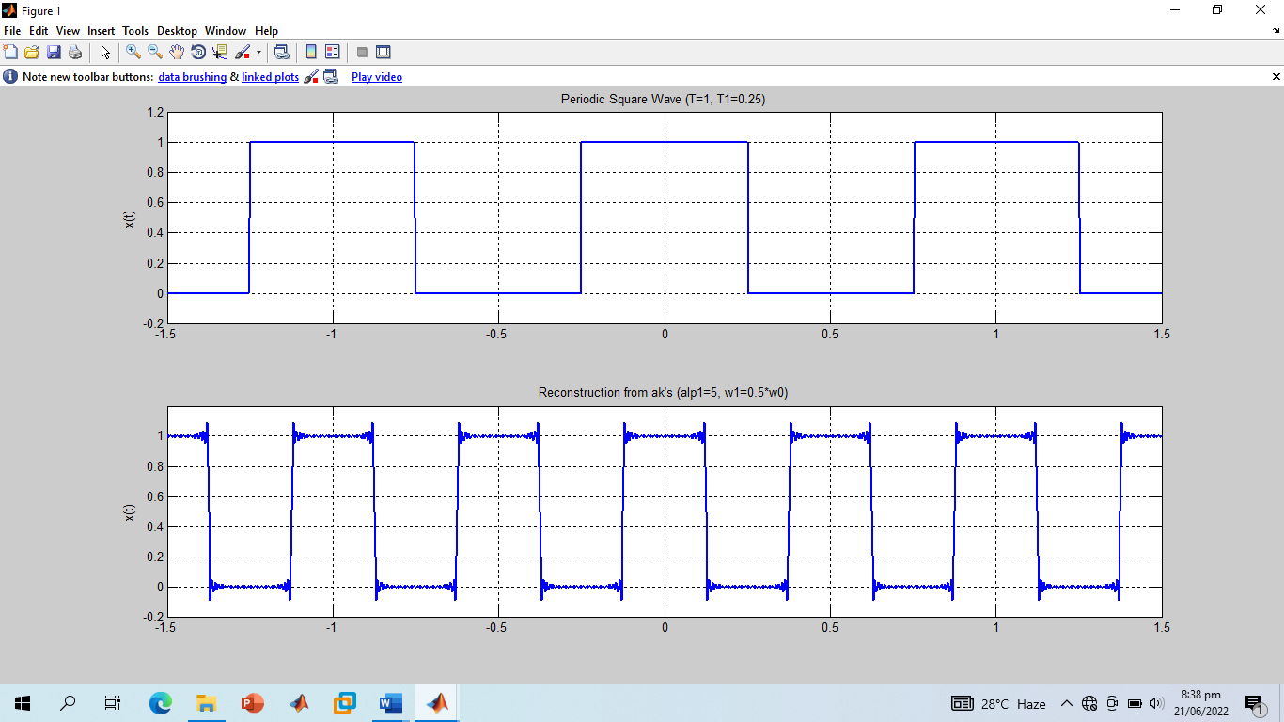

**------------------------------THE END------------------------------**